**TOKYO**   
**Heavy rains and water management**

**Arthur Guillot – Le Goff**15/01/2022

Table of contents

Abstract 2

Introduction, The Japan nature paradox 3

Heavy rain in Tokyo, an analysis of the situation 4

The path between urbanization and heavy rain 6

Flood management in the megacity and its readiness for the future 7

Conclusion 9

📚 Bibliography 10

🖼️ List of figures 10

*Spatial planning for flood protection - University of Ljubljana  
Autumn semester of 2021*

# Abstract

|  |
| --- |
| Tokyo, the Japanese capital, is the largest megacity in the world. For several decades now, the number of heavy rains has been increasing. Japan is a country with many natural disasters and it is interesting to note that Japanese culture, through the prism of Shinto philosophy, has always been close to this nature but passively undergoing its course. A behaviour that is still found today in the way of providing solutions to the problems of flooding. If it was always easy to make the link between urban densification and the increase in temperature, the increase in temperature and the increase in rainfall. It was not until more complex numerical models were developed that heat island phenomena and heavy rains were linked. As the megacity has become aware of the dangers of these rains, it has developed an important protection system with water bypasses, reservoirs and dikes. These solutions are certainly effective, but they solve the problem by tackling the consequences and not the cause. |

Keywords

▶ heavy rains  
▶ heat island phenomenon   
▶ flood protection  
▶ traditional philosophy  
▶ natural disasters

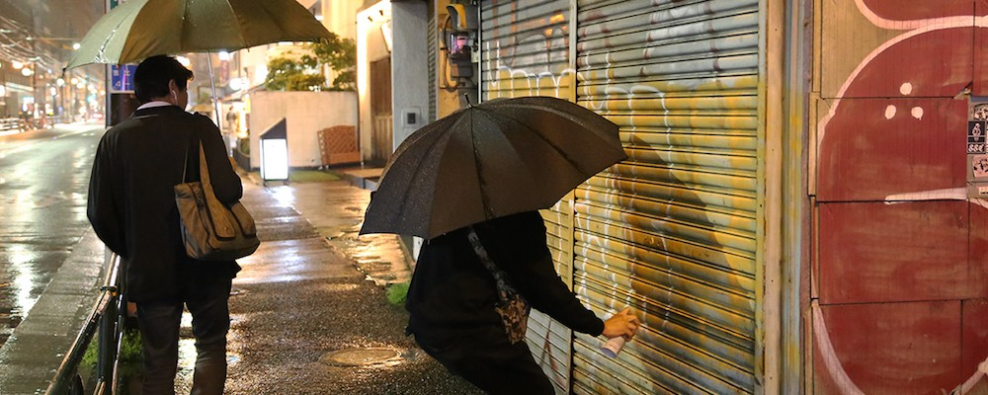

***WANTO, Painting a fill-in***

📷 ***Ray Mock***

# Introduction, The Japan nature paradox

The city of Tokyo, now the world's largest megalopolis with 35 million inhabitants within a 50km radius, has its origins in the medieval city of Edo built in the 16th century. The image we usually have of modern Tokyo, with its crowded intersections and advertising screens permanently lit on skyscrapers, is far from the original style of the city. Indeed, we can describe Edo as the first ecological city: populated by the Japanese court, it is described as a garden city: a mosaic of residence, park and river where the free spaces being cultivated almost allow the city to function in closed circuit. This lifestyle close to nature is inherent to Japanese culture and the Shinto philosophy (Guillot - Le Goff, 2020).

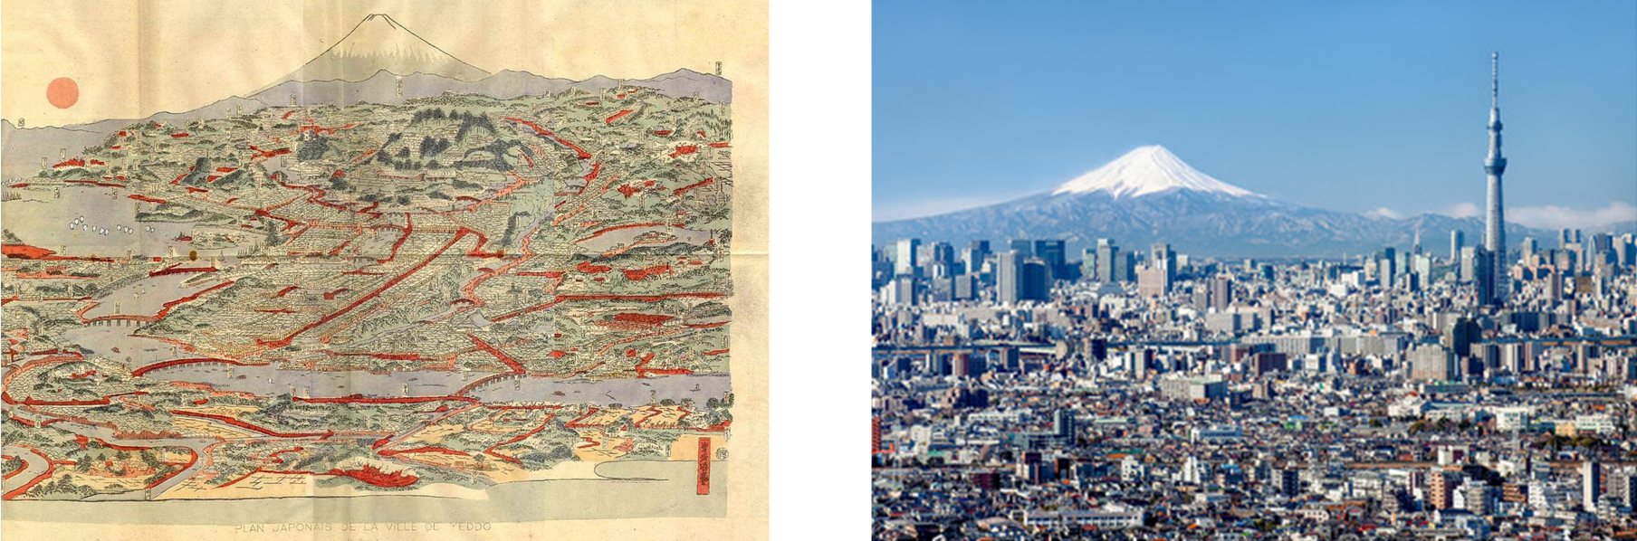

Figure 1 - Edo city stamp and nowadays Tokyo skyline (Wikipedia, Jan Christopher Becke)

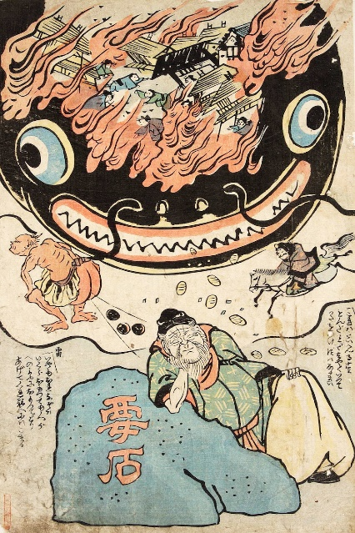This line of philosophy associates a kami, a natural deity, with each natural element. deity that must be respected. These deities are associated with almost all natural phenomena and are generally provided with two different faces. The first being *nikitima*, the harmonizing spirit and *aratama*, the raging spirit. For example, the kami associated with earthquakes is represented by a giant catfish causing destruction around it, if it is enraged but can bring good fortune when it is at peace. The important point of this spirituality, which raises a first paradox, is that the human cannot prevent the *kami* from going into a rage and can only appease it by practicing religious rituals. As a result, and according to Shintoism philosophy we would tend to see that the Japanese resigns against the cause of the disasters but faces the consequences (Suhara, 2020).

This relationship that the Japanese have with nature is characterised by various other paradoxes. One of the first examples and the impact of the monsoon. It is at the same time a source of wealth because it allows agriculture but also the cause of numerous natural disasters (floods, typhoons). Historiallywise, Japan has accepted a confusion between technology and its link with nature. Indeed, During the 19th century, Japan quickly opened its borders to European and American technologies. However, Japan did not import Western natural philosophy, which had formed the background of scientific civilisation. Most Japanese accepted Western scientific products as distinct from the traditional view of nature (Keiichi, 2017).

Figure 2 - Namazu to Kaname-ishi or 'Namazu and the Foundation Stone', (1855), artist unknown. Source: Tokyo Metropolitan Library

|  |
| --- |
| *“For people who live in a country where disasters of earthquakes and floods are frequent and unpredictable, a natural impermanence permeates their internal organs and bowels as memory inherited from remote ancestors*.”  **Kamo no Chōmei** |

# Heavy rain in Tokyo, an analysis of the situation

Firstly, it is interesting to look at temperature measurements and rainfall records to get an initial view of the changing climate situation. The data shown below are from the World Meteorological Organization and more precisely from the Tokyo weather station[1]. I then looked at the average temperature over a year and the amount of rainfall over the last decades between 1875 and 2020.

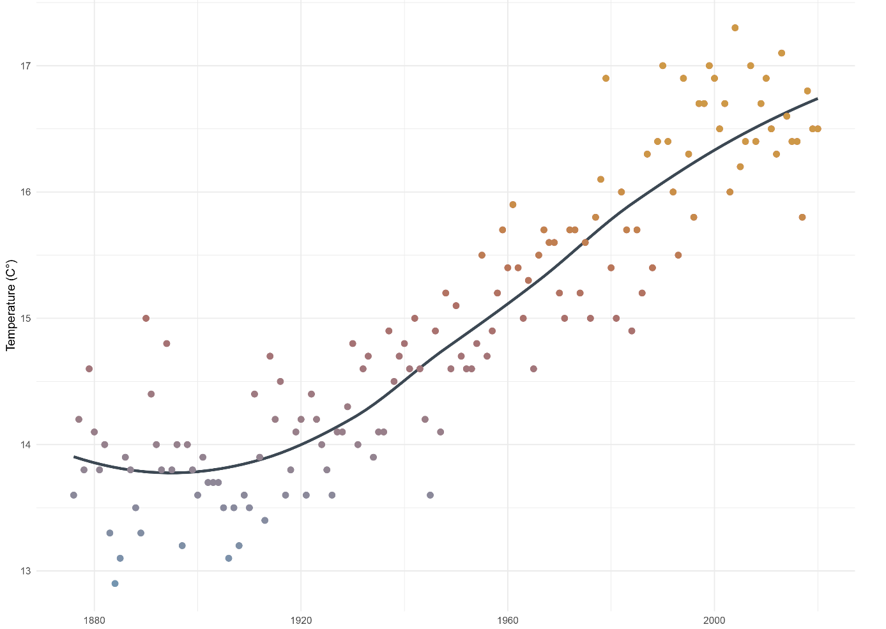

Figure 3 - Average annual temperature measured at the WMO weather station in Tokyo

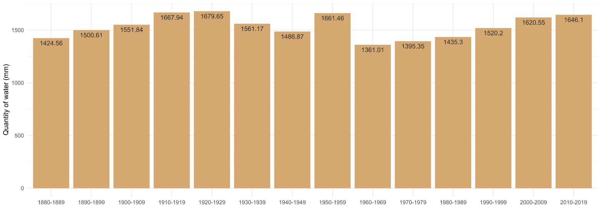

Figure 4 - Histogram of rainfall per decade measured at the WMO weather station in Tokyo

The first obvious observation is that the average annual temperature has increased by more than 3°C. This result is shared in numerous publications such as (Brimblecombe et al., 2020) who precise that 4.4 times faster than the global average temperature. The observation of the quantity of water can leave us more sceptical despite the fact that since 1960 (corresponding to the post-WW2 period) there has been an almost linear increase. Another data point that is interesting to look at, specifically when looking at heavy rainfall, is the amount of water per rainfall. This is highlighted in the work of (Hiroko, 2017) which reports that the number of rainfalls measured at more than 2 inches (50mm) have increased by 30% and those over 3 inches (76mm) by 70% over the last 30 years. We can then conclude that Tokyo is experiencing significant warming and increasingly heavy rainfall.

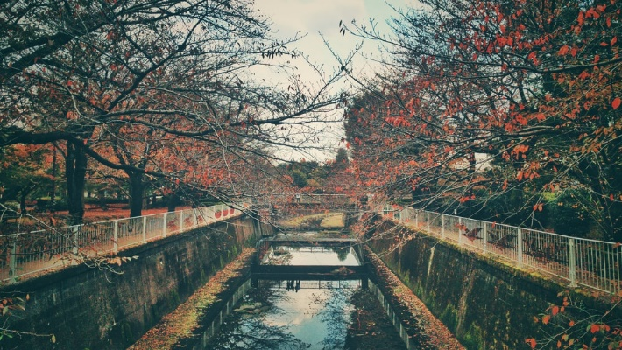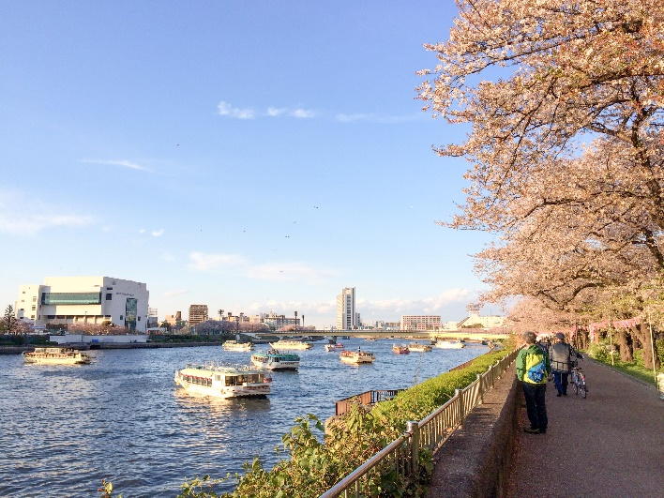The megalopolis of Tokyo is crossed by 8 rivers, the most important being the Sumida River, the Ara River and the Edo River. The first one runs through the centre of the city and the last two through the suburbs. In the 50's and 60's many parts of the city were under water due to typhoons and the fact that some areas were below sea level. If the old dykes of that time were sufficient for a while, there are more and more concerns with the increase of the rains and urbanisation that leaves less room for water drainage (ABC Science, 2020). This is not the only concern of the Japanese, who are experiencing many more natural disasters in recent times, making Tokyo the “riskiest metropolitan area in the world” according to Swiss Re[2] .

Figure 6 – Photo of the Sen river across Sengawa park

Figure 5 - Photo of the Sumida river

# The path between urbanization and heavy rain

The major hypothesis proving the link between increased urbanisation and increased rainfall is the heat island effect of the Tokyo megacity. Brimblecombe gave us a good definition of this phenomenon. The urban heat island localized temperature rises generally seen to arise from the lack of green and water areas, the exhaust heat caused by the human activities and a poor urban ventilation (Brimblecombe et al., 2020).

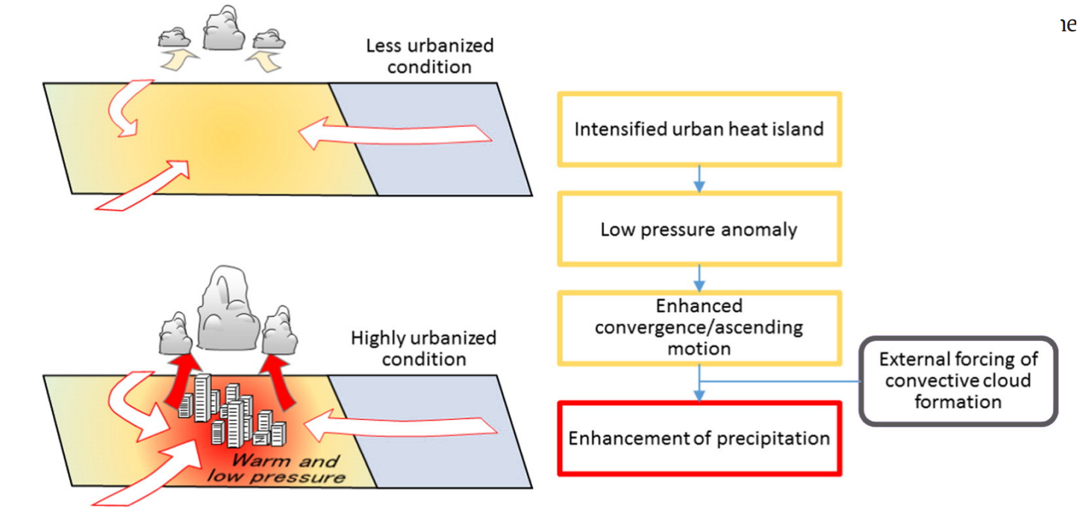

Figure 7 - Schematic illustration of the impact of urban temperature rise on precipitation and relevant process (from N. Seino et al. / Urban Climate 23 (2018) 8–35)

According to the paper from (Matsumoto et al., 2017), the location of Tokyo may induce some error in the identification of this urban heat island as the city is affected by the Asian Monsoon on the one hand and by its coastal nature on the other. In order to confirm the link between increasing temperature and increasing urbanisation, numerous numerical models have been carried out. In addition to confirming this phenomenon, they also indicate that the Tokyo heat island is "extended". it suggests that it has much larger horizontal dimensions, extending into its suburbs. To summarise simply, on this surface and rising up to one kilometre in altitude, temperatures are abnormally high when the measurements and simulations are compared to atmospheric standards. This phenomenon is all the more surprising given that the opposite is also observed in heavily vegetated areas, such as parks for example. These green spaces generate a "cooling effect" and simple measurements allow us to observe that the Shinjuku Gyoen park is colder than its surroundings in summer and warmer in winter (the trees providing better thermal insulation).

We can then look at the second link we are trying to establish, the one stating that the increase in temperature causes an increase in rainfall. In his study (Oh et al., 2021) looked at three major urban regions in East Asia: Huang-dong, Seoul and Tokyo. His analysis shows that despite differences between the regions, the conclusion is that urbanised areas show a greater increase in precipitation as a function of temperature.

It would be sophistry to jump to a conclusion by connecting two independently studied physical systems. And even if, studies revealed early (during the 70s) the possibility of a link between heavy rainfall and increasing urbanisation, we had to wait for serious and complete numerical simulations to be able to statistically affirm that there was indeed a link between urbanisation and the increase in heavy rainfall, with the increase in temperature in between. It is this type of complete model that (Seino et al., 2018) study focuses on. Indeed, they simulate two cases: a dense urban hypothesis and a less urbanized one and by using data monitored between 2006 and 2013.

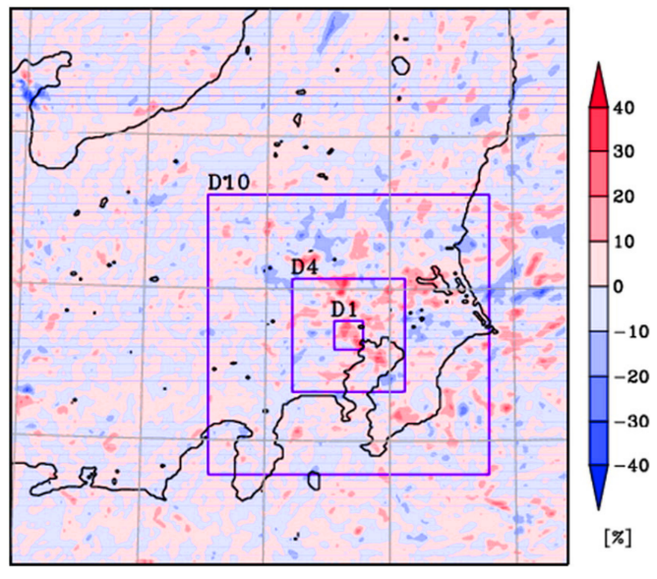The result of these simulations can be summarised in the following figure. Comparing the difference in precipitation between the two scenarios we observe that in the case of an area with a high urban density there is about 30% more rainwater than in an urban area with a lower density. Furthermore, the study shows that an increase of 1°C in Tokyo statistically requires an increase in the amount of rain in August, demonstrating that the impact of urbanisation is a key factor in Tokyo's changing weather patterns.

I think it is also important to point out that Tokyo is not the only region affected by heavy rain. It is fair to mention the disaster of 2018, which caused severe flooding in the south of the country. Unprecedented events that leave one wondering about the lack of preparation for such sudden typhoons, despite the fact that the country is used to natural disasters (Tokyo Climate Center, 2018). This episode of heavy rain is also attributed to the crossing of warm air movements, an effect very similar to urban heat islands triggering rainfall.

Figure 8 - Map displaying the simulated rainfall amount in the case of very dense urbanisation minus the simulated rainfall amount where urbanisation is low (results reduced to a percentage)

# Flood management in the megacity and its readiness for the future

Despite the tragedy, the events of June and July 2018 have also in a way updated the guidelines for future flood protection and a report by the River Council for Social Infrastructure Development informs us about what I think will be the next big steps in the fight against flooding in Japan (KOIKE, 2018):

* Creating a cooperation between all social sectors to better prepare for the next floods: “Rebuilding Flood-conscious Societies”,
* The construction of new, more durable dykes and temporary shelters for the affected population,
* The installation of "water-proof" structures, or at least structures that do not accumulate and block large quantities of water,
* Upgrading safety factors by taking better account of the impacts of global warming,
* Enhance scientific research on these issues.

Specifically, in Tokyo, flood protection is organised around the development of three main types of infrastructure:

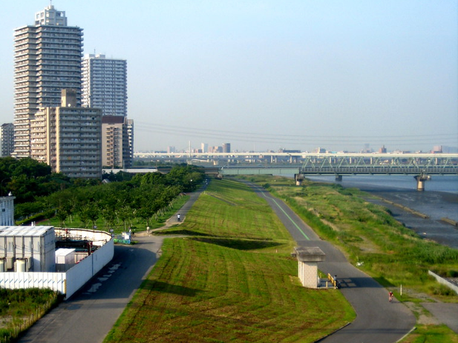

Firstly, by using flood retaining structures such as "super levee" a high standard improved levee that can support much more water flow and also designed to be multifunctional which combines spaces for transport, leisure and vegetation, improving also the landscape around the river. Projects initiated in the early 90s and still being developed today (Stalenberg & Vrijling, 2009) (Nakamura, 2016).

Figure 9 - Photo of a super-levee on the Edogawa in Tokyo (William Veerbeek)

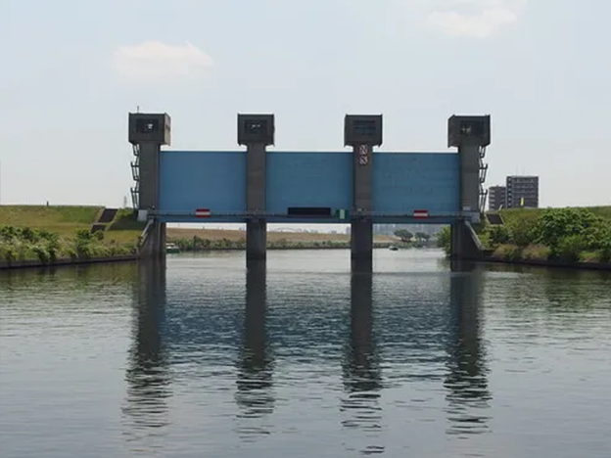

Figure 10 - Photo of the Iwabuchi Sluice Gate

Last but not least is the Kasukabe surge tank. Its primary purpose is to break the momentum of the rainwater and discharge it into the Edo River more calmly. This concrete cathedral is connected to several collectors in the city centre and is operated by pumps capable of handling flows of up to 200m3/sec. It is designed to manage a one in a 200-year flood. Despite its cost of $3 billion, it appears to have already saved $1.1 billion since it was commissioned in 2006 (ABC Science, 2020).

Secondly, the creation of various channels operating through large gates allowing the management of unpredictable flood events. For example, the Blue Suice Gate on the Arakawa River (pictured opposite) protects the whole of eastern Tokyo and thus 5.4 million people. These gates located outside the city and operate in such a way that when there is a risk of flooding: they close, causing the water to flow into a canal and dumping it directly into the sea (ABC Science, 2020).

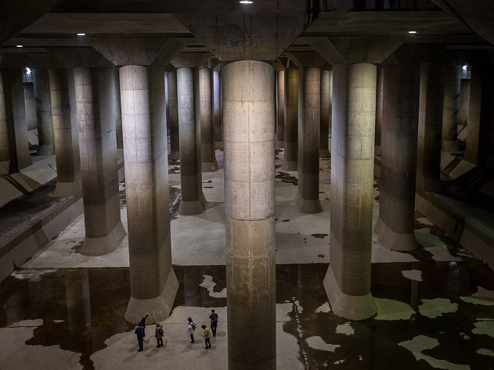

Figure 11 - Photo of the Kasukabe surge tank

# Conclusion

In conclusion, I think it is important to look back at the steady we have been making about Japanese philosophy towards natural disasters. If in traditional mythology unexplained disasters had an explanation justifying the passivity of the population, today the causes of heavy rains are well-known.

However, Japan is still struggling to see the impact of global warming on its capital. And even though popular belief has gradually faded, the Japanese continue to deal with the consequences rather than the causes. A situation which, we can admit, has improved significantly in recent years. The recent Olympic Games have brought an idea of renewal, and Tokyo has been able to transform itself and try to counteract global warming. For example, the construction of many parks should combat the urban heat island effect that we have been experiencing and unfortunately the effects of these many efforts will not be visible immediately.

It is through more sustainable urban planning that the city will stop boiling because the momentum of global warming will not improve the situation. A complicated situation for a society and a people who find it difficult to reconcile culture, nature and the future

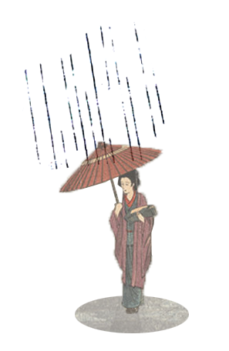

# 📚 Bibliography

ABC Science. (2020). *Tokyo Flood Prevention | Insane underground tunnel system in Japan*. https://www.youtube.com/watch?v=Rp2l6nFIsZA

Brimblecombe, P., Hayashi, M., & Futagami, Y. (2020). Mapping Climate Change, Natural Hazards and Tokyo’s Built Heritage. *Atmosphere*, *11*(7), 680. https://doi.org/10.3390/atmos11070680

Guillot - Le Goff, A. (2020). Tokyo entre culture et nature. *UR05, UTC*. https://arthur-glg.github.io/aglg_science/portfolio/file/aglg%20-%20Nature%20et%20culture%20%C3%A0%20Tokyo.pdf

Hiroko, T. (2017, October). Tokyo Is Preparing for Floods ‘Beyond Anything We’ve Seen. *The New York Times*.

Keiichi, N. (2017). The Great Earthquake Disaster and the Japanese View of Nature. *Journal of Japanese Philosophy*, *5*(1), 1–10. https://doi.org/10.1353/jjp.2017.0000

KOIKE, T. (2018). *Flood Risk Management for Wide-area and Long-lasting Rainfall.pdf*. River Council for Social Infrastructure Development.

Matsumoto, J., Fujibe, F., & Takahashi, H. (2017). Urban climate in the Tokyo metropolitan area in Japan. *Journal of Environmental Sciences*, *59*, 54–62. https://doi.org/10.1016/j.jes.2017.04.012

Oh, S.-G., Son, S.-W., & Min, S.-K. (2021). Possible impact of urbanization on extreme precipitation–temperature relationship in East Asian megacities. *Weather and Climate Extremes*, *34*, 100401. https://doi.org/10.1016/j.wace.2021.100401

Seino, N., Aoyagi, T., & Tsuguti, H. (2018). Numerical simulation of urban impact on precipitation in Tokyo: How does urban temperature rise affect precipitation? *Urban Climate*, *23*, 8–35. https://doi.org/10.1016/j.uclim.2016.11.007

Suhara, E. (2020, December 15). *How Do Asian Religions Explain Natural Disasters? Introducing Theodical Arguments in Asia—The Case of Shinto Religious Ideology in Japan*. https://medium.com/illumination-curated/how-do-asian-religions-explain-natural-disasters-1-2caa1df6a4e

Tokyo Climate Center. (2018). *Primary Factors behind the Heavy Rain Event of July 2018 and the Subsequent.pdf*.

# 🖼️ List of figures

Figure 1 - Edo city stamp and nowadays Tokyo skyline (Wikipedia, Jan Christopher Becke) 2

Figure 2 - Namazu to Kaname-ishi or 'Namazu and the Foundation Stone', (1855), artist unknown. Source: Tokyo Metropolitan Library 2

Figure 3 - Average annual temperature measured at the WMO weather station in Tokyo 3

Figure 4 - Histogram of rainfall per decade measured at the WMO weather station in Tokyo 4

Figure 7 - Schematic illustration of the impact of urban temperature rise on precipitation and relevant process (from N. Seino et al. / Urban Climate 23 (2018) 8–35) 5

Figure 8 - Map displaying the simulated rainfall amount in the case of very dense urbanisation minus the simulated rainfall amount where urbanisation is low (results reduced to a percentage) 6

Figure 9 - Photo of a super-levee on the Edogawa in Tokyo (William Veerbeek) 7

Figure 10 - Photo of the Iwabuchi Sluice Gate 7

Figure 11 - Photo of the Kasukabe surge tank 7

1. https://www.data.jma.go.jp/obd/stats/etrn/view/monthly_s3_en.php?block_no=47662&view=1
2. Swiss Re (insurance company), 2014 study of natural disaster risks